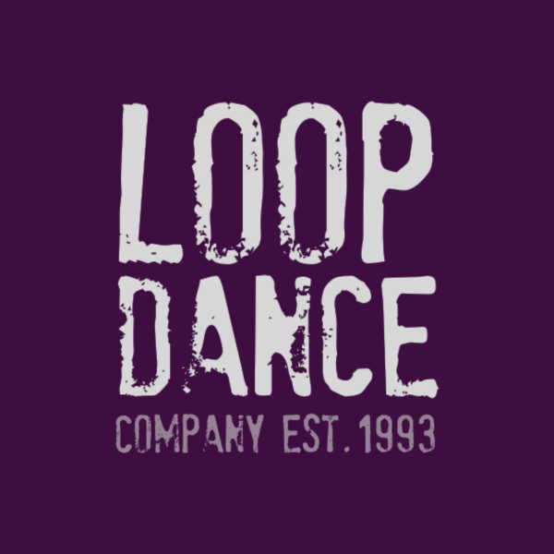

Loop Summer Intensive - Sign up

Thank you for your interest in our Loop Summer Intensive!
This is a summer programme of classes with Loop Dance Company hosted at The Brook Theatre and also available online via Zoom.

Please see timetable attached for timings and details of classes.

Name
Age (If you are under 18, please complete the additional consent form)
Email Address
Phone Number
Home Address
Emergency Contact
Are there any medical concerns we should be aware of?
Would you like to be signed up to our mailing list?

We would love for you to join us for the whole programme, however we wish to open up these classes for those that may only wish to join for a few sessions. Please indicate below the classes you would like to join. If selecting 1 day or 1 class/ multiple classes, please let us know below which classes these will be from the timetable attached.

Options | Amount/ Details of which sessions you would like to attend.
3 Day Pass (All sessions - £120 per person)
1 Day Pass (£50 per person)
1 Class Pass (£13 per person)

Many thanks,
Loop Dance Company
Photograhpy: Merlin Hendy

